There is just one program counter, one path to data memory, and one instruction stream, one data stream (SISD).  A computer may operate on a single piece of data and carry out one instruction at a time.  A standard computer (sequential).

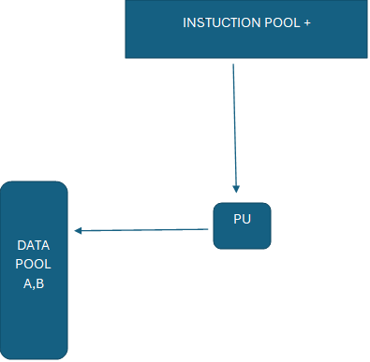

Several minicomputers connected by a computer network make up the minicomputer model, a distributed computing system.

Extension of the Time-Sharing System. After logging onto his or her home minicomputer, the user can use telnet to access a distant computer. High-performance devices, databases, and resource sharing.For instance, the ARPAnet

The workstation server is a client-server architecture in which a central server is connected to a number of workstations (clients).Migration of processes .The user logs on to his or her own computer first.A hefty job might go to one of the distant workstations if there are any idle ones. Issues:

  What happens if someone logs in to the distant computer? • How to move a job; • How to locate an idle workstation.